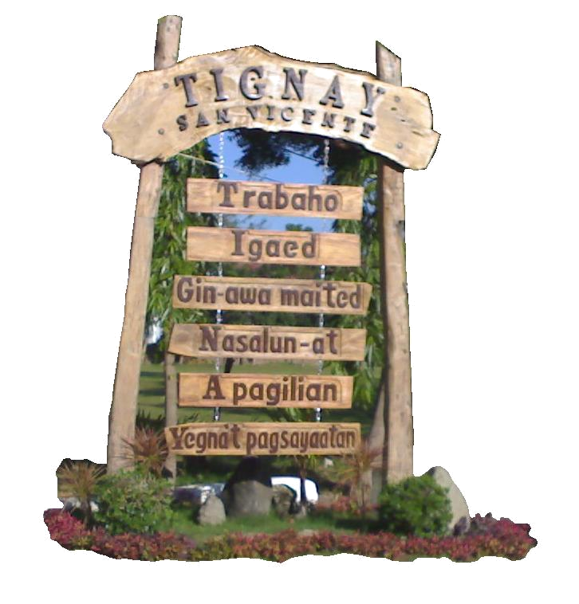


CITIZEN’S CHARTER
San Vicente, Ilocos Sur

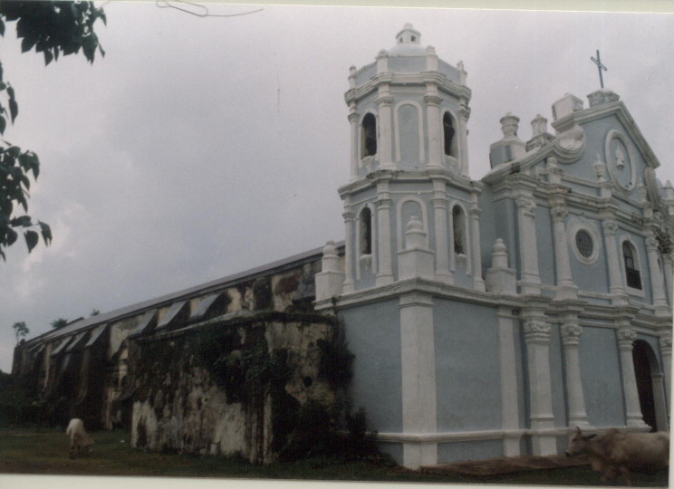
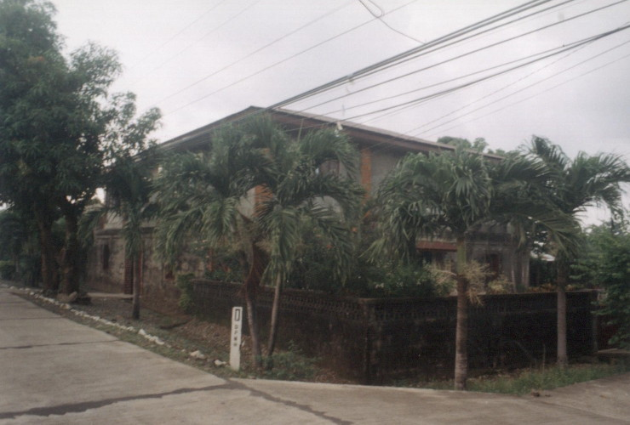
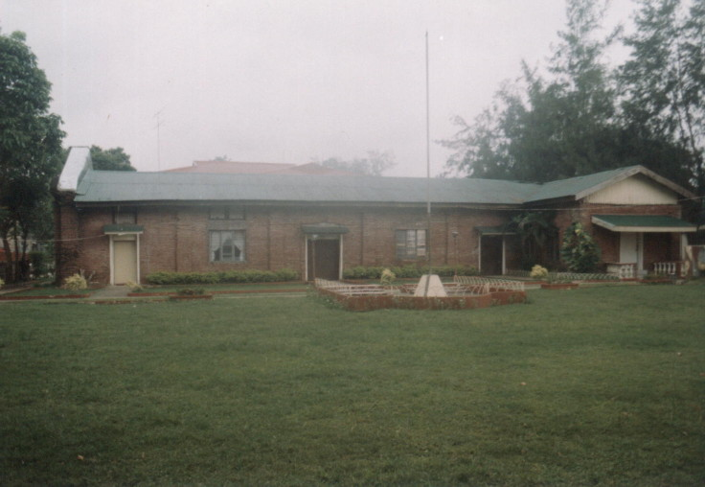
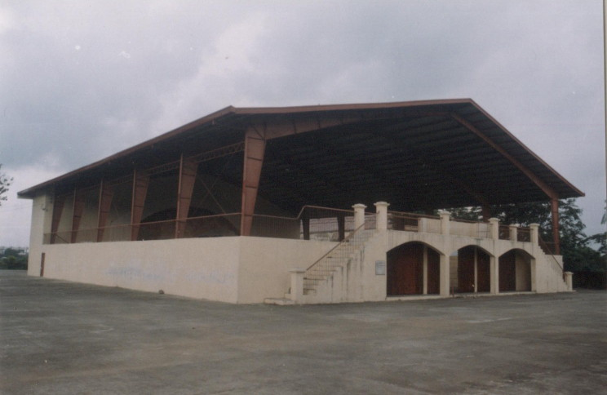
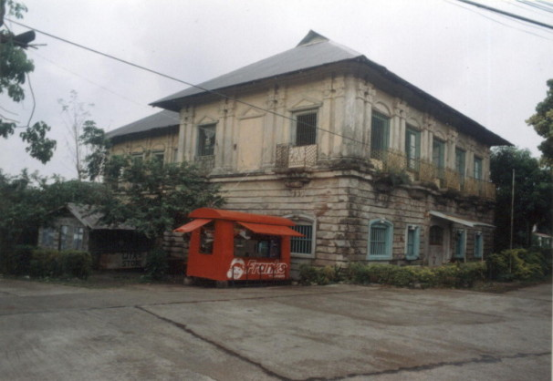
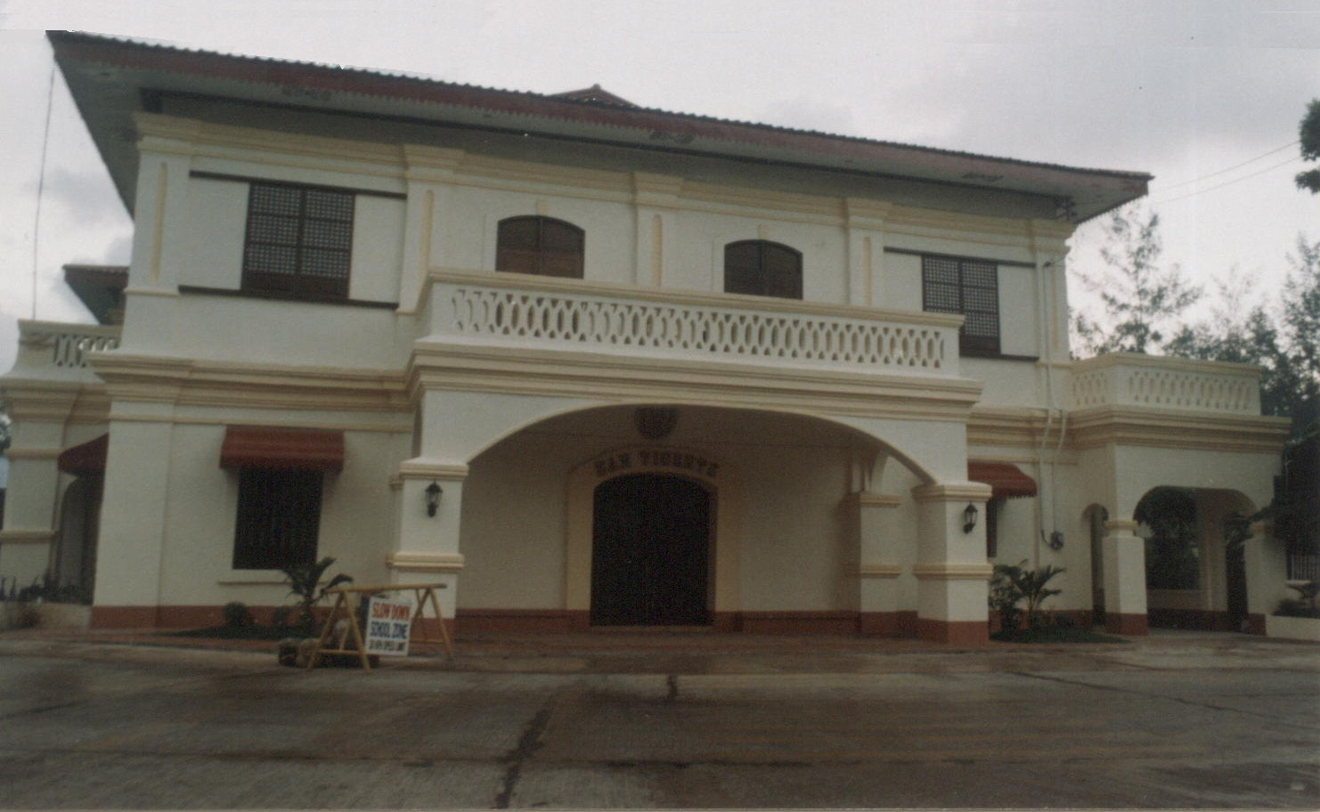
Our Vision

“A globally competitive furniture and agri-aquatic center of the North governed by highly dedicated and result-oriented public servants towards a self-reliant and God-fearing community.”

Mission

- Self-sufficiency in food production
- Increase income of farmers, fishermen and furniture makers.
- Production of competitive furnitures
- Eco-friendly production strategy
- Increase local revenues
- Deliver quality, sustainable basic health, education & social welfare services
- Quality infrastructure facilities
- Improve work attitude and performance of employees through effective HRD training
- Enhance employees productivity and performance
OUR BATTLECRY

T - rabaho
I - gaed,
G - in-awa maited.
N - asalun-at
A - pagilian,
Y - egna’t pagsayaatan. SAN VICENTE

Our Customers / Clients

General Public

Our Services

RURAL HEALTH UNIT

- Maternal Care – Monday to Friday
Beneficiaries : Women on their reproductive age
- Child Care – Monday to Friday
Beneficiaries : Children
- Immunization – Every first and last Wednesday of the month
Beneficiaries : Infants 0-12 months old
- Family Planning – Monday to Friday
Beneficiaries : Would-be and married couples
- Dental Care - Every Friday
Beneficiaries: All residents
- Water Sampling
- Chlorination
- Environmental Sanitation
- Inspection of Sari-Sari Stores / Carinderias
- CBC, Platelet, Urinalysis, Teralysis (Monday to Friday)
- Blood Chemistry – Sugar (PBS), Cholesterol, Triglyceride, Uric Acid, HDL / LDL BUN, Coreatinine (Monday to Friday)
- Widal Test (Monday to Friday)
- Hepa B (Monday to Friday)
- Blood Typing (Monday to Friday)
- Blood Chemistry (Monday to Friday - Morning only)

DEPARTMENT OF SOCIAL WELFARE AND DEVELOPMENT OFFICE

- Self-Employment Assistance (SEA)
- To provide financial assistance to indigent families that will serve as their capital to start a livelihood or income-generating project.
- Beneficiaries: Indigent families in the 7 Barangays
- Fund provided: ceiling Php3,000.00 – Individual
Php5,000.00 –Family
- Requirements:
1. Certificate of indigency issued by the Punong Barangay; and
2. Certificate of Good Moral
- Aid in Crisis Situation (AICS)
- To provide financial assistance to indigent families in crisis
- Beneficiaries: indigent families in the 7 barangays
- Fund Provided: ceiling of Php1,000.00( amount depends on the need of the beneficiary)
- Requirements:
1. Certificate of Indigency issued by the Punong Barangay
2. Go to the Municipal Social Welfare Officer for application and assessment
3. Approval of application by the LCE and preparation of voucher
4. Release of fund
- Other Financial Assistance
- Beneficiaries: Indigent families in the 7 barangays
- Burial Assistance
- Required documents:
1. Certificate of Indigency issued by the Punong Barangay
2. Death Certificate
- Medical Assistance
- Required documents:
1. Certificate of Indigency issued by the Punong Barangay
2. Medical Certificate
- Other Medical Assistance Services
- Referral to PCSO for Hospitalization Assistance (Surgical Operation)
Requirements:
1. Certificate of indigency issued by the Punong Barangay
2. Medical Abstract/Official Receipt issued by the hospital
3. Statement of Account issued by the hospital
4. Written request of patient or representative
- Assistance to Senior Citizens
- Beneficiaries: aged 60 and above
- Senior Citizens Identification Card (ID)
- Present Community Tax Certificate (CTC) and two (2) 1x1 ID Picture to the
Municipal Social Welfare Officer
- Purchase Slip(Medicine)
- Present Senior Citizen ID to the Municipal Social Welfare Officer

- Purchase Booklet(Grocery)
- Present Senior Citizen ID to the Municipal Social Welfare Officer
- Pre-Marriage Counselling
- Conducted every Tuesday at 9:00 AM

LOCAL CIVIL REGISTRAR OFFICE

- Marriage License
- Required Documents:
1. Birth certificate of applicants
2. Family Planning and Pre-Marriage Counseling Certificate
3. Parents Consent (if applicant is 18 y/o but below 21 y/o but below 25
y/o)
4. Death Certificate of deceased spouse (if applicant widow / er)
5. Certificate of Legal Capacity to Contract Marriage (if applicant is
foreigner)

- Birth Certificate
- Requirements:
1. Sworn Statement of the mother
2. Baptismal Certificate
3. Marriage contract
4. No record form from the census
5. Voter’ certificate
6. Barangay Certificate

- Death Certificate

PHILIPPINE NATIONAL POLICE

- Police Clearance
- Required Documents:
1. Barangay Clearance
2. Community Tax Certificate
3. One (1) copy of 2x2 latest picture

OFFICE OF THE MUNICIPAL MAYOR

- Business Permit / Mayor’s Permit
- Required Documents:
1. DTI Registration
2. Community Tax Certificate
3. Barangay Clearance
4. Fire Safety inspection Clearance
5. BIR Clearance
6. SSS Clearance
7. Philhealth Clearance
8. MTO Clearance from business tax, rentals and other incidental fees
9. Sanitary / Health Clearance

OFFICE OF THE MUNICIPAL ENGINEER

- Building Permit
- Required documents;
1. Five (5) sets of plan/specification duly signed by licensed Civil
Engineer/architect (for 2 storey building only)
2. Tax declaration/current tax receipt of land title
3. Community Tax Certificate
NOTE: houses w/ and area of 20 sq.m. and below and houses constructed of
temporary materials are exempted. Exemption is to be issued by the Municipal
Engineer.

- Occupancy Permit
- Required Documents:
1. Building Permit
2. Certificate of Completion
3. Fire Safety Clearance
4. Permit Fee
5. Community Tax Certificate
6. Others as may be required

DEPARMENT OF INTERIOR AND LOCAL GOVERNMENT OFFICE
- Death Benefit Claims for Barangay Officials
1. Properly accomplished death Benefits Claim form with the following documents:
a. Death Certificate
b. Certificate of Incumbency issued by the DILG Officer
c. Marriage Certificate
d. Birth Certificate of the claimant to show proof of relationship to the
deceased barangay official duly authenticated by the Local Civil
Registrar (if claimant is son/daughter)
e. Birth Certificate of the deceased (if claimant is parent)
2. Endorsement of the DILG Officer
NOTE: Death Benefit Claims must be submitted in four copies. The original
copy and three (3) photocopies marked CERTIFIED TRUE COPY

- Grant of Barangay Official Eligibility (BOE)
A. For Elected Barangay Officials
1. Application (CS Form 101-A) properly filled up and notarized
2. Certification of the Punong Barangay
3. Certification of the Municipal Mayor
4. Certification of the DILG officer with the following:
a. date of birth
b. place of birth
c. date of assumption
e.g. SK – June 1, 1996 to Aug. 14, 2002
5. Oath of Office
6. Endorsement of the DILG Officer
B. For Appointed Barangay Officials
1. Requirements # 1 to 5
2. Appointment
3. Endorsement of the DILG Officer

NOTE: Required certification and documents in duplicate

- Foreign Scholarship Programs for Local Government Units
1. Biodata with 2x2 picture
2. Certified true Copy of Records and Diploma
3. Official Service Record
4. Official Actual Duties and Responsibilities Certified by Immediate Supervisor
5. Performance Rating for the Last 2 Rating Period
6. List of trainings and Seminars Attended
7. Certification of No Service Obligation from Previous Training Attended
8. Certification of No Service Obligation from Previous Training Attended
9. Certification of Clearance from any Administrative and Criminal Charges
10. Written Consent of Spouse (if married)
11. Recommendation from the Local Chief Executive
12 Endorsement fro the DILG Regional Director

NOTE: Applicants must submit two (2) sets of above documents to the DILG-CLGSC Chairperson thru its Secretariat c/o Local Government Academy, 6th Foor Agustin Building, Emerald Avenue, Ortigas Center, Pasig City; Documents #12 and #13 must be submitted only when accepted to attend the scholarship program; All nominees will be officially informed of date of interview thru the DILG Regional Office c/o LGA Regional Coordinator; Interview will be conducted by NEDA Pasig. (For further inquiries, call the DILG-CLGSC National Secretariat c/o Local Government Academy (LGA) 6th Floor Agustin Building, Emerald Avenue, Ortigas Center, Pasig City at telephone numbers (02) 634-5873/634-1883 and ask for MINA LIMAWAG, DILG-CLGSC Secretariat Scholarship Section, Education and Training Division)

LGU Offices

Office of the Municipal Mayor
This is the office of the Local Chief Executive of the municipal government. This office is headed by Hon. Jose C. Tabanda III the Municipal Mayor himself, who exercises general supervision and control over all programs, projects, services and activities of the Municipal Government.

Office of the Sangguniang Bayan
This office is the legislative body of the municipal government. It is a separate entity placed parallel with that of the Office of the Municipal Mayor to signify equality and independence of each other’s responsibility. The following compose the Sanggunian with the Municipal Vice-Mayor, as the Presiding Officer and the 8 regular Sangguniang Bayan Members with the 2 ex – officio members.
This office approved ordinances and pass resolutions necessary for an efficient and effective Municipal Government.

Office of the MPDC
This office maximizes the planning and development capability of the municipal government. Inter-office coordination and assistance on plans and programs preparation, plans and integration and local government council secretariat services are considered as the operational components of the said office. This office is headed by Engr. Juan P. Rialubin, the Designated - Municipal Planning and Development Coordinator.

Office of the Municipal Accountant
This office preserves proper checks and balances in the financial operation of the
municipal government.
Accounting and Internal Audit Services are the operational components of this office. This is headed by Miss Fatima Clarisse R. Rocero, Municipal Accountant, assisted by two Bookkeepers and one Bookbinder II.

Office of the Municipal Civil Registrar
Civil Registration Program Development and Implementation, Document Registration and Preservation, Coordination with the National Statistics Office in Education Campaigns for vital Registrations, Assistance in Demographic and Statistics Preparation and Issuance of Certified Copies of Registered Documents are the operational components of this office. This office is headed by Mr. Henry R. Ranches, the Municipal Civil Registrar assisted by one (1) Clerk II and one (1) Bookbinder II.

Office of the MSWO
The following are considered as the operation of this office.

  - Child Development and Protection;
  - Nutrition Service;
  - Youth Welfare Programs
  - Welfare Programs for the Elderly and Disabled;
  - Social Upliftment Services;
  - Disaster Relief Assistance;
  - Inter-agency coordination on Social Welfare and Development for both Government Office and NGO’s
This office is headed by Mrs. Maribien R. Reclusado.

Treasurer’s Office
This office is headed by Mrs. Corazon Raga, the OIC Municipal Treasurer. The following may be considered as the operational components of this office:
- Tax Education and information;
Field Inspection of private, commercial or industrial establishments;
  - Disbursements;
  - Cash Receipts.
This Office maximizes the financial operations of the Municipal Government.

Budget Office
This office is headed by MR. JOSE R. REYNO JR., the Municipal Budget Officer. The following may be considered as operational components of this Office:
  - Inter-office coordination and assistance on budget preparation
  - Budget integration and reports preparation

Agricultural Office
This office is enabling the municipal government to maximize its attention on its agricultural programs.
The following may be considered as the operational components of this office:
  - Research and Development;
  - Extension Services;
  - Information and Education;
  - Animal Protection Services;
  - Inter-agency coordination on agricultural productivity of governmental offices and NGO’s.
This office is headed by. MRS. LILIA R. REALINA, the municipal Agricultural officer and assisted by four (4) agricultural Technologist.

Municipal Health Office
This office ensures maximum attention to the health services needs of the municipal government.
The following are considered as the operational components of this office;
- Health policies, ordinances and programs development implementation;
- Sanitary Inspection;
- Health Information and Education;
- Health Services Administration;
- Inter-agency coordination and health policies and programs for both
government offices and NGO’s
This office is headed by DR. AMADO A. VIESTA JR., the Municipal Health Officer assisted by three (3) Midwives, one (1) nurse, one (1) Sanitary Inspector and one (1) Medical Technologist.

Engineering Office
This office ensures maximum attention to infrastructure projects of the municipal government The following maybe considered as the operational components of this office:
- Infrastructure planning and development;
  - Construction and maintenance;
  - Quality control;
  - Inter-agency coordination on architectural planning and design of government agencies and NGO’s
This office is headed by Engr. Juan P. Rialubin, the Municipal Engineer.

Assessor’s Office
This office enable the municipal government to maximize its revenue generating capability . Tax mapping, real property valuation and assessment , real property identification and accounting, field surveys for assessment rolls and assessment records and reports are considered as the operational components of the said office.
This office is headed by Mrs. Concepcion R. Arcellana.

Municipal Administrator’s Office
This office is an extension of the Office of the Municipal Mayor. The following may be considered as the operational components of this office:
- Special Projects Development and Management
- Inter-Office and Inter-Agency Coordinator and Assistance
- Organizational Development.
This office is headed by Mr. Angelito P. Rojo.

The National Agencies operating in the municipality have their respective offices at the Municipal Hall. These are the DILG, DAR, Municipal Circuit Trial Court, the COMELEC, BIR, the Philippine Postal Corporation, and the PNP.

We’d Like to Hear From You…

For your suggestions, comments for us to improve our services, please get in touch thru any of the modes stated below to the Local Government Unit – San Vicente, Ilocos Sur

Tell us what you think of our services

___________________________
___________________________ _______________________
___________________________ Print Name & Signature

My experience with your office is satisfying because

___________________________
___________________________ _______________________
___________________________ Print Name & Signature

My visit to your office was not satisfying because

___________________________
___________________________ _______________________
___________________________ Print Name & Signature

Help Us Serve You Better …

Our aim is to provide you with quality services

To do this, we need you to:
- Provide accurate information and documents
- Be open and honest in your dealing with us
- Comply with what is required of you by law.
- Respond quickly to our request.
- Have all relevant information documents ready when dealing with us.
- Contact us if we made a mistake.
- Treat our staff with courtesy and respect.
- Provide any compliments, suggestions or complaints.

To give a compliment, or make a complaint suggestions: Contact us by Telefax No. (077)722-8320 or drop it to our Suggestion Box.

AUTOMATIC EXTENSION OF PERMITS AND LICENSES

If a government office or agency fails to act on an application and/or request for renewal of a license, permit or authority subject for renewal within the prescribed period, said permit, license or authority shall automatically be extended until a decision or resolution is rendered on the application for renewal:

Provided

That the automatic extension shall not apply when the permit, license, or authority covers activities which pose danger to public health, public safety, public morals or to public policy including, but not limited to, natural resource extraction activities.
FEEDBACK AND REDRESS MECHANISM
FEEDBACK MECHANISMS
In availing/securing any of the services in the Municipality of San Vicente, Ilocos Sur as defined in this Charter, a client/applicant who may feel that the service provider or office personnel are not providing the expected courtesy, transparency, honesty and efficiency, the applicant is strongly encouraged to bring this to the attention of the Mayor or to the head of office concerned.
The head of office will call the concerned staff and discuss the matter in the presence of the applicant/feedback giver. If the applicant is not satisfied with the response of the staff and the way the department head resolve the issue, the applicant can also go directly to the Human Resource Management Officer for proper settlement.
All offices are provided with Customer Feedback forms for every applicant/client to fill up and submit the same to the Mayor, HRMO or to the Department Head concerned.
Applicants/clients are also encouraged to suggest ways and processes to further improve the quality of service. These suggestions will be taken up by the Steering Committee in consultation with the Task Force members.

COMPLAINTS PROCEDURES
FILING PROCEDURES/STEPS
If applicants or clients are dissatisfied and may not be happy with the services being provided/availed of, he/she can secure a complaint form from the Complaint Desk, accomplish the forms with the supporting documents if any and submit the accomplished complaint forms to the Desk Officer of the Complaint Desk located at the ground floor or send through the Post Office if the complainant cannot go to the Desk Officer.
MANAGEMENT OF THE COMPLAINT
- Upon receipt of the complaints whether personally submitted or mailed, the Desk Officer shall forward the complaint to the Municipal Mayor for his information. The Mayor shall route the same to the head of the department where the subject of the complaint (staff) belongs.

- The head of the department shall call the attention of the concerned staff and inform him/her about the complaints raised against him/her to answer the allegations within three (3) days.

- After receipt of the answer from the subject employee, the department head shall notify the complainant in writing and inform her/him of the answer of the subject employee (admitting the mistake being done, apologize with a promise not to do it anymore).

- The Mayor/department head shall inform the public and thank them for airing the mistakes being done by employees and will ensure that they will do their best to review policies and procedures to stop from happening again. They will also ensure that complaints against any employee shall be addressed, monitored and treated in order to improve the delivery of services and ensure that the best and quality services are provided to all their clients.
We, the employees of the municipality of _____________, commit to extend quality service of the above cited services, equipped with the values of discipline, courtesy, honesty and team work we pledge to perform with excellence with the corresponding response time.

FRONTLINE SERVICES RESPONSE TIME
1.
2.
3.
4.

NAMES OF FRONTLINERS
Position

